Database System Engineering and Distributed Backend Development
Course Code: 25CS1302E
ACID PROPERTIES & ISOLATION
Roll No:2520030189
Name:Alluru Akshaya
Section:7

Query-1:
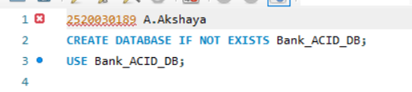
Output:
Query-2:
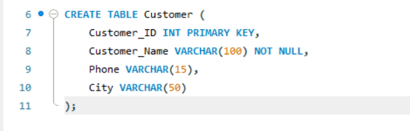
Output:

Query-3:
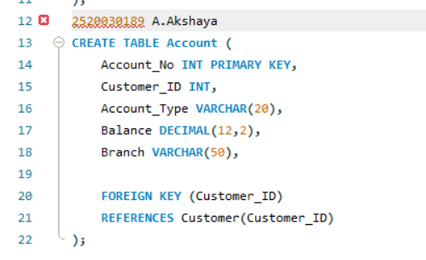
Output:
Query-4:
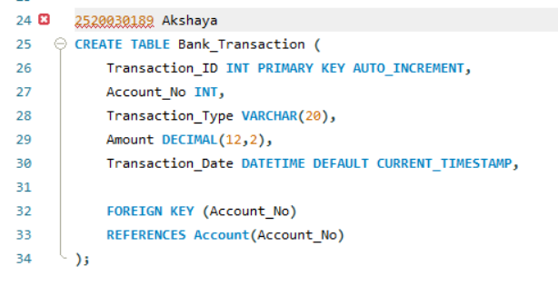
Output:
Query-5:
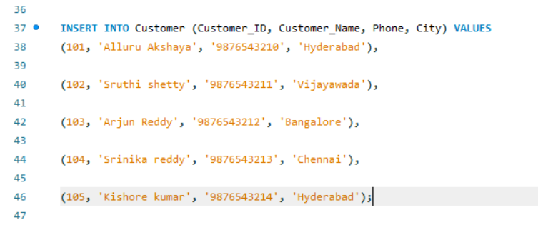

Output:
Query-6:
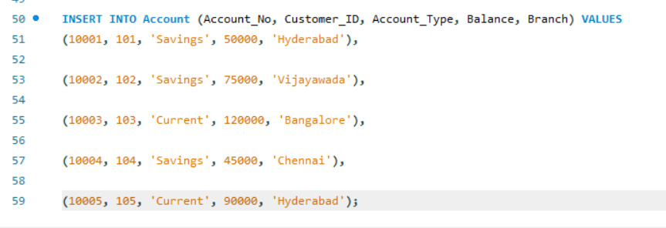
Output:
Query-7:
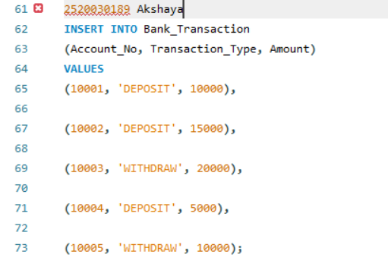
Output:

Query-8:

Output:
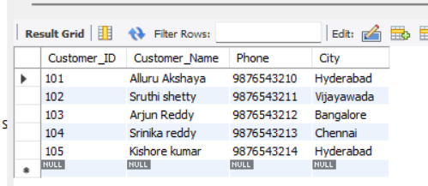
Query-9:

Output:
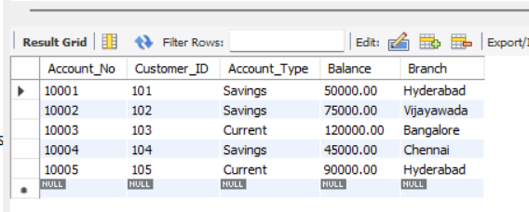
Query-10:


Output:
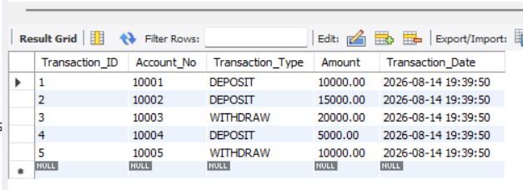
Query-11:
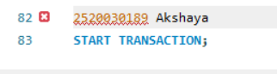
Output:
Query-12:
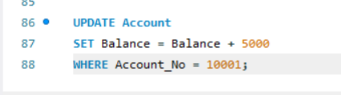
Output:
Query-13:
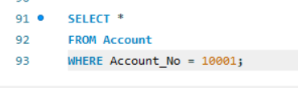

Output:
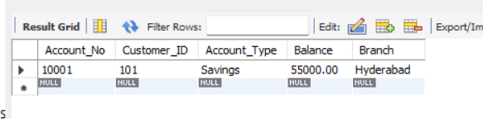
Query-14:

Output:
Query-15:
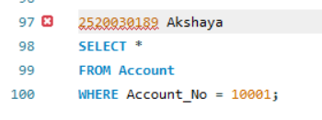
Output:
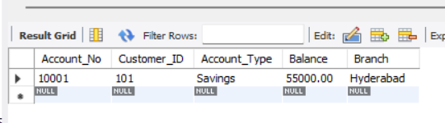
Query-16:
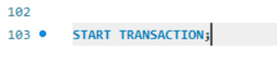
Output:
Query-17:
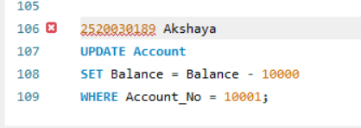
Output:
Query-18:
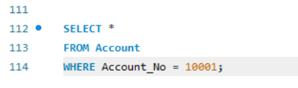
Output:
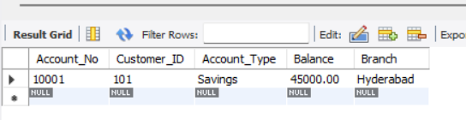
Query-19:

Output:
Query-20:
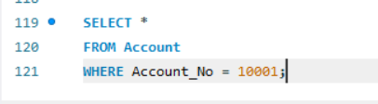
Output:
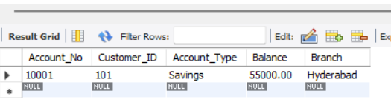
Query-21:
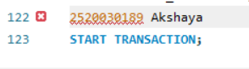
Output:
Query-22:
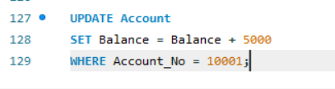
Output:
Query-23:
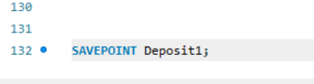
Output:

Query-24:
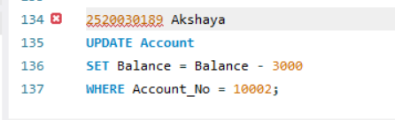
Output:
Query-25:
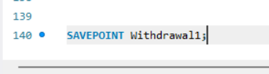
Output:
Query-26:
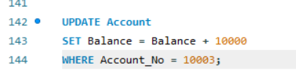
Output:
Query-27:
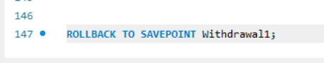
Output:

Query-28:
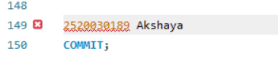
Output:
Query-29:
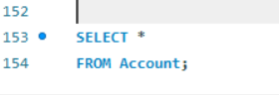
Output:
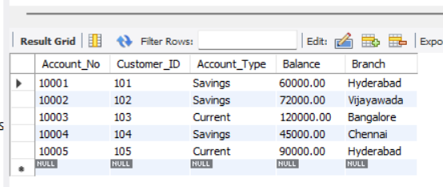
Query-30:
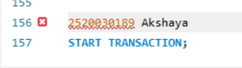
Output:

Query-31:
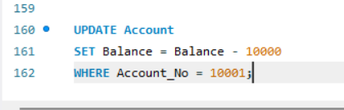
Output:
Query-32:
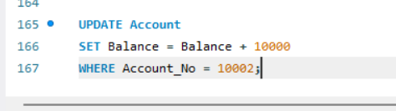
Output:
Query-33:
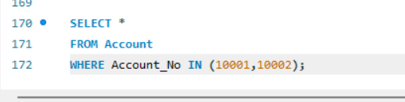
Output:
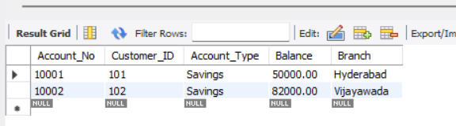

Query-34:

Output:
Query-35:
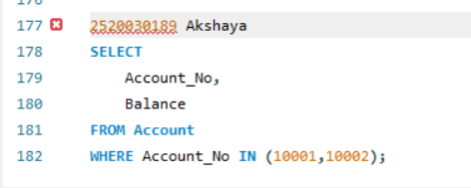
Output:
